Re: Request for funds For a third assistant

Honorable County Board Members:

As you may know, I have recently had turnover in my office. My assistant David Sternau left to work for the Clinton County State’s Attorney’s Office. I was lucky enough to find an assistant from St. Clair State’s Attorney’s Office whose grant funding recently ran out and was willing to start on short notice. Her name is Jessica Carr Martin (jcarr@fayettecountyillinois.org), and I am excited to add her expertise in gun crimes to my staff. I am also pleased that I was able to find an assistant so quickly as it was a lengthy issue to find David.

In my exit interview with Mr. Sternau, he cited the large workload as the main reason he was leaving. When my former assistant Brenda Duke left, she also gave the high workload as the main reason for leaving. The caseload was also an issue for my first assistant Amanda Ade-Harlow.

To add to the pressure of the caseload, the court docket is extremely backlogged due to COVID-19 and by scheduling changes made by the former Chief Judge of the Circuit. Because of COVID-19, the docket of cases in Fayette County has continued to increase, while the opportunity to try them in court has all but stopped. I have only been allowed to try two cases in the fourteen months following COVID-19 restrictions. Consequently, our already unmanageable docket has swelled to a point that I will continue to lose good people if I do not take action.

My newest assistant is already voicing concern over the workload as it is still, and is expected to remain, at a level that exceeds what is expected and standard for an Assistant State’s Attorney.

Request

I am requesting a budget increase in order to hire a Junior Assistant State’s Attorney at $50,000 plus benefits. This will allow me to redistribute workload more in line with the workload that is standard for State’s Attorney’s Offices.

Caseload Statistics and Concerns

While we are not the largest county, we have an extremely large docket that is just as big as much larger counties. Although the Illinois Criminal Justice Information Authority (ICJIA) is several years behind in processing data from the Courts and the Courts have declared themselves un-FOIA-able, which means we are unable to request further information, we were able to download historical data to analyze caseloads. I was also able to use judici.com to gather some information across counties, although because the website does not allow web page scraping, I had to gather information by hand, which limits my ability to gather data for analysis.

Historically, we significantly exceed the average of felony cases filed per capita in the circuit. Felony cases are, by far, the most time- and resource-intensive cases that we try. Our felony filing rate per capita is higher than Cook, Sangamon, and St. Clair Counties.

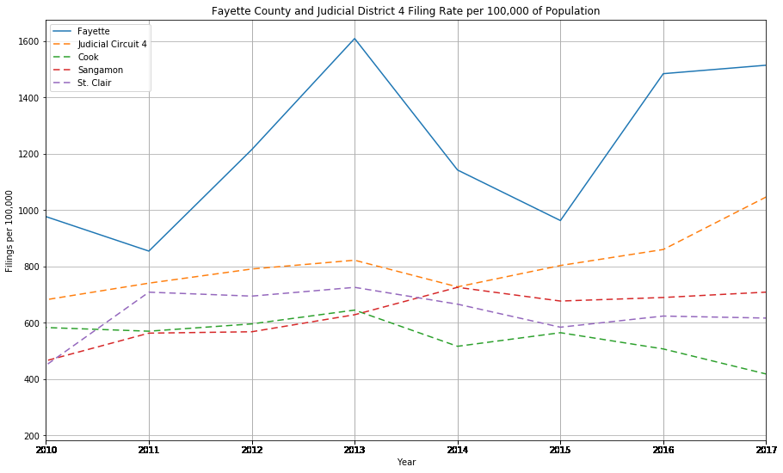

As a note, a portion of the filings in 2013 was due to working through the backlog of police reports left unreviewed by the previous state’s attorney, and the reduction in filings in 2014-2015 corresponds to a 2014 change in tracking which moved DUIs to their own category, decreases in arrests for aggravated assault, auto theft, robbery and burglary in 2014 and 2015, and a large decrease in larceny/theft arrests in 2015.

In hard numbers, Fayette County has historically ranked towards the top of the surrounding and similar counties for the number of felony cases filed. Below are the number of felony cases filed for similarly situated counties within Judicial Circuit 4 for 2010-2017. This data was also accessed from information from ICJIA.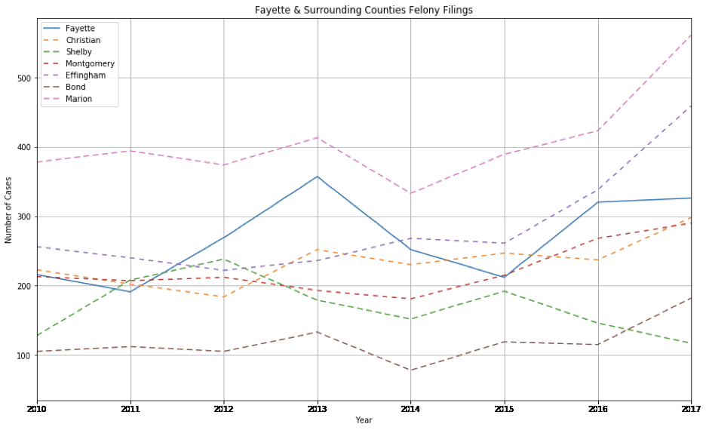

Of the Counties on this above visualization, only Fayette and Shelby have one assistant. In the last few years prior to the last election, the Shelby County State’s Attorney has outsourced a portion of its work to an outside attorney. Since the most recent election, the new Shelby County State’s Attorney has brought on the former Macon County State’s Attorney as an assistant and heavily relies on his expertise to avoid hiring another assistant.

To my knowledge, Fayette County Assistant State’s Attorney staffing levels have not changed in at least 20 years, although there is a clear upward trend in the number of felony cases filed.

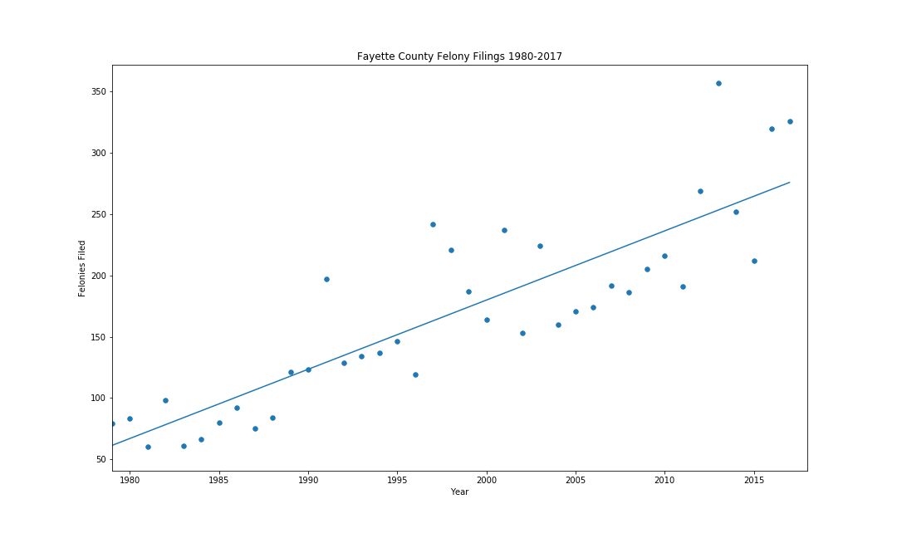

As more recent data is unavailable from ICJIA, I used judici.com to find the number of felony filings from the last few years for several comparable counties in the circuit. I also called several State’s Attorneys to find out information on their assistants.

|  |  |  |  |  |  |  |  |
| --- | --- | --- | --- | --- | --- | --- | --- |
| **Fayette and Surrounding Counties Assistants and Felony Filings** | | | | | | | |
| **County** | **Fayette** | **Effingham** | **Bond** | **Montgomery** | **Shelby** | **Marion** | **Christian** |
| Number of Assistants | 1 | 2 | 2 | 2 | 1 | 2 | 2 |
| Assistant Salaries | $68,000 | $75000, $52,000 | Not Available | $75,000, $52,000 | $72,000 | Not Available | Not Available |
| 2019 | 354 | 541 | 156 | 334 | 162 | 483 | 405 |
| 2020* | 284 | 329 | 146 | 401 | 123 | 377 | 327 |
| *COVID-19 resulted in most of the state seeing a significant decrease in arrests/filings and is not representative of a typical year | | | | | | | |

Through May 5, we have filed 140 felony cases, well on track to beat the record of 354 in 2020, and unfortunately, we do not have the resources to enable us to work through the backlog of cases and process the new cases.

Although having one assistant has made my office a great value for the taxpayers of Fayette County, it is detrimentally affecting our ability to handle cases. Because we do not have the staff necessary to process the case volume, we have had to make some hard choices, such as reducing office hours with the public, prioritizing only serious and violent crime, and limiting administrative functions. Even though we have had to prioritize, we still file more misdemeanor cases than Christian, Shelby, and Bond Counties, with only Shelby having one assistant.

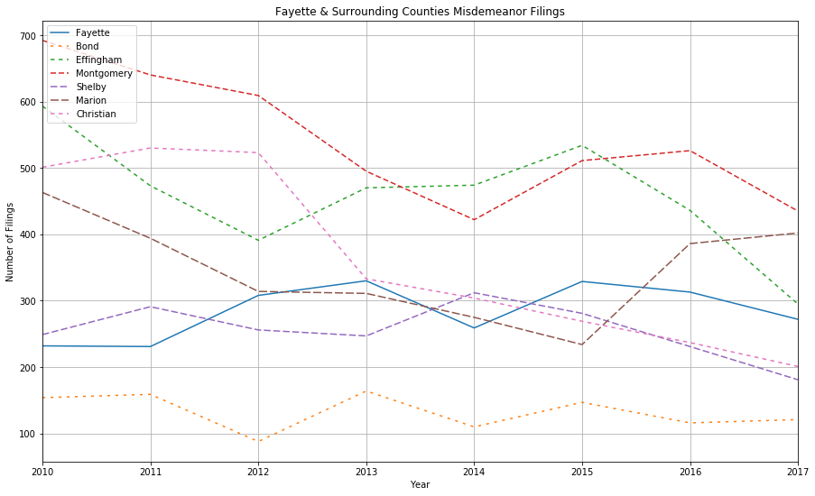

Actions Already Taken

I have already made an effort to streamline my operations and reduce the workload for my assistants. For example:

* I moved the responsibility of the juvenile caseload from Mr. Sternau to myself. This means that I must plan to be unavailable for anything but juvenile law on Thursdays.
* Before Ms. Duke left, I had moved the responsibility of drug court from her to myself as a way of reducing her workload. This resulted in my being unavailable for anything but drug court on Fridays.
* After Ms. Ade-Harlow left, the County outsourced contract negotiations, and I took on the responsibility for reviewing all police reports instead of sharing that responsibility with assistants.
* We no longer regularly do probable cause hearings on felonies and instead have moved to Grand Jury indictments. This allows us to process the equivalent of 20-40 or more probable cause hearings in one day; however, this still requires time to process and prepare outside of the day that we hold the Grand Jury.
* COVID-19 and circumstances have forced us to do only phone meetings and reduce our time spent with the public.
* We have moved to an electronic system instead of paper.
* We rely on our victim-witness coordinator to do many of the meetings with victims and witnesses that many State’s Attorneys in small counties handle themselves; however, her role is limited due to legal requirements.

Other Factors Causing Increased Workload

Unfortunately, there is little that we can do to change the amount of time that each case takes, or the number of police reports that come in. Our secretarial staff is also unable to legally take on any more work from attorneys. Changes in management of the Circuit Court and in statutes have also made our jobs more difficult and time-consuming. For example:

* Our caseload made up so much of the shared drug court that the Circuit requires us to do our own, which increased our administrative burden.
* Changes in statutes have reduced State’s Attorneys’ ability to refuse candidates for drug court. This has resulted in judges allowing defendants into drug court that were not good fits and increased the number of hearings and administrative burden.
* Currently, the judge in charge of traffic court directs everyone who wishes to have Court Supervision to talk directly with me, which means that I must spend a great deal of time dealing one-on-one with defendants in traffic cases. While I do not feel that this is a good use of my time and County funds and I am trying to change this, I cannot dictate to the Court how they direct defendants to contact my office.
* As of 1-1-2018, PA 100-03 requires probation for first offenders on methamphetamine possession and some other drug offenses, which means that many drug defendants must be convicted of at least two offenses in a short period of time before they can be sentenced to jail or prison time. This results in many defendants being released to offend again, thus increasing both the administrative burden (to revoke probation) and the case burden for their subsequent cases.
* Judicial concern for defendants’ rights has caused judges to allow defense attorneys to continue cases repeatedly, resulting in cases being backlogged, extra time in court, and extra administration, while also making it more difficult to try cases (State’s Attorneys are bound by time constraints that must be met and are limited on continuances).
* Circuit management and COVID have resulted in limited hours for judges to be in the Courthouse. This results in extra time and administrative burden in scheduling, and administrative burden in locating judges. This also results in time spent going to judges’ homes to get signatures for warrants, as well as times in which nothing can be done because there is no judge available.
* The Circuit Clerk’s office is rejecting many more filings than in the past for technical issues. This is requiring duplicative work resulting in a loss of efficiency and concerns over the completeness of court files, which necessitates an attorney to review the results of these rejections.
* Increases in the technical nature of some crimes, such as child pornography, have increased the complexity of cases and the need to coordinate and work with other agencies, such as the Attorney General.

Outlook and Plans for New Position

I do not anticipate that there will be a reduction in crime in the near future. In fact, there is a strong upwards trend in methamphetamine arrests. These arrests are of particular concern because these defendants are likely to be statutorily required to be released on probation. The following is from the Illinois State Police UCR web page.

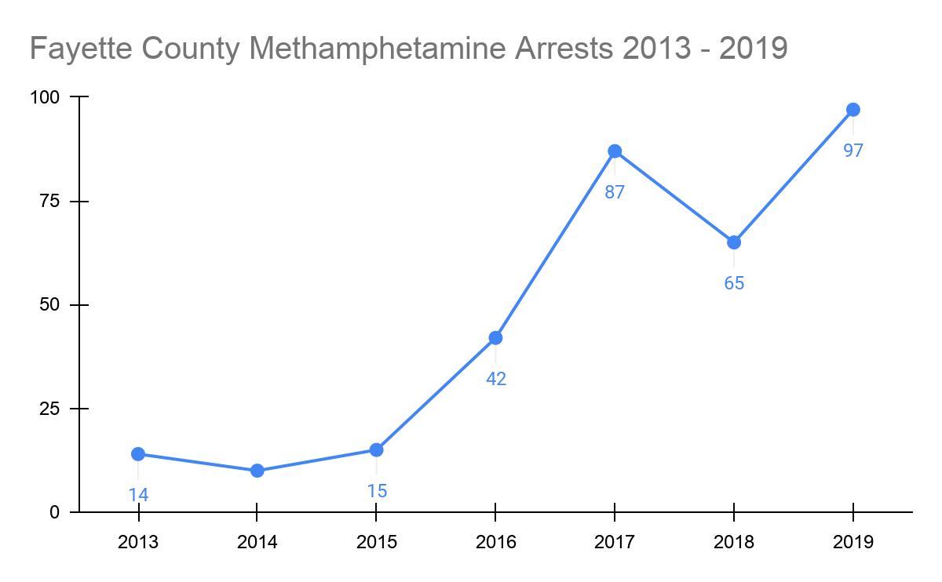

Overall, there has been an increase in arrests in Fayette County from 2013 to 2019. The number of arrests in 2019 showed a 38% increase over 2013. We have no reason to believe that this trend will reverse. I review every report that comes in, sometimes several times, in order to make filing decisions. An increase in arrests is likely to increase the number of open cases in the county.

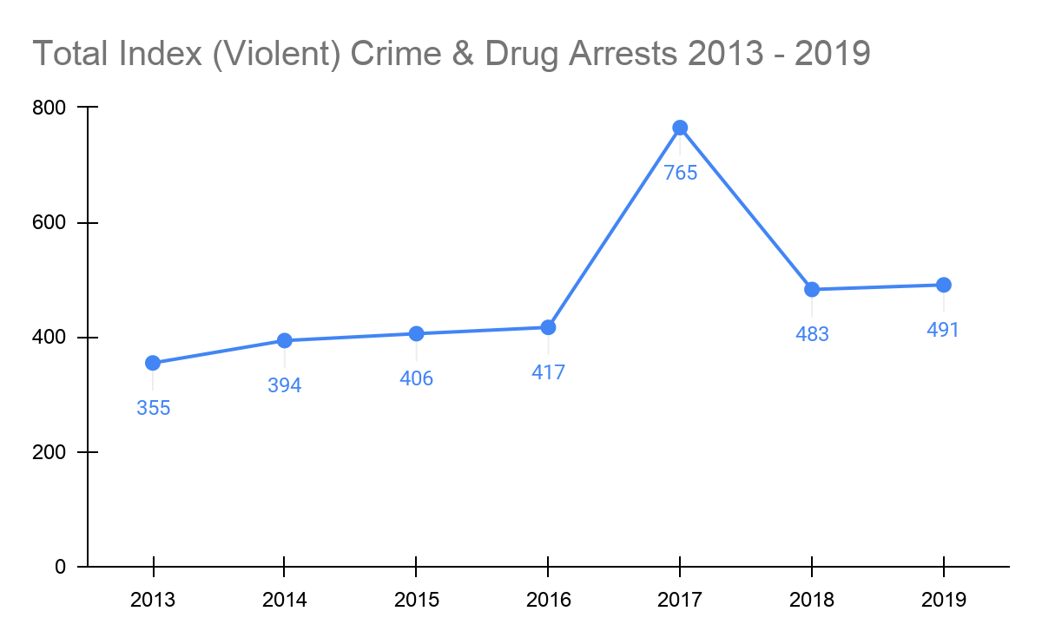

The recent anti-policing bill will most likely result in an increase in cases and an increase in the complexity of prosecuting cases, as they will require many “non-dangerous” drug offenders to be booked, or ticketed, and released while they are still actively high and can continue whatever behavior caused them to be arrested. As it is currently written, it will require the court to be in session during the weekend, which will be completely unsustainable with a staff of two. There are currently ongoing discussions on changes to this bill, but it is unclear if this will be changed.

The 2020 legalization of cannabis is not anticipated to have a significant impact on caseload, as only misdemeanor amounts were legalized. In fact, according to the Illinois State Police UCR data downloads, in 2019, there were only 12 reported Cannabis arrests. It is unclear from the data whether these were felonies or misdemeanors.

The new position will allow me to distribute workload to levels that are reasonable and expected for Assistant State’s Attorneys. However, for the first year to two years, this position will serve to assist in working through case backlog, handling traffic court, preparing files and court documents, and making offers to defendants. This will allow me to more quickly work through cases and give more attention to each case, allow time for prosecution of more cases, give more time to the public and to administrative matters important to the Board, such as contracts and human resource issues.